# Paper/Part Three – “Top-Down controls on sediment deposition on a fringing reef flat embayment in American Samoa”

## Introduction

The complex spatial and temporal interaction of terrigenous sediment inputs, sediment resuspension, and hydrodynamic circulation can significantly alter the quantity, composition and residence time of sediment deposited on corals, causing subsequent impacts on coral ecology (Storlazzi et al., 2009). Depending on the interacting hydrodynamic processes on the reef, increased terrigenous sediment supply to an embayment can increase sediment deposition on corals (Draut et al., 2009), or have no effect (Hoitink and Hoekstra, 2003). Furthermore, coral stress and mortality from sediment in the water column and deposition is a complex process depending on hydrodynamics, sediment biogeochemistry, and coral morphology and physiology (Fabricius, 2005; Weber et al., 2012), making it difficult to quantify coral stress caused by sediment. Given the increase in sediment discharge to coastal waters caused by anthropogenic watershed disturbance on tropical islands, understanding how the interaction of flood-supplied terrigenous sediment and water circulation controls sediment deposition and residence time is essential for identifying and mitigating coral health impacts.

**Hydrodynamic controls on sediment deposition and residence time**

Hydrodynamic circulation driven by wind and waves can deflect plumes of suspended sediment away from coral, limiting turbidity stress from light attenuation (Hoitink and Hoekstra, 2003; Muzuka et al., 2010), and/or advect suspended sediment over the coral and out to sea before it can be deposited. Wave energy, either from remotely generated surface gravity waves or local wind-driven waves, is typically limited on shallow reef flats, but can cause high orbital velocities that resuspend previously deposited sediment or prevent sediment deposition, with the cumulative effect of shortening sediment residence time. Ogston et al. (2004) showed that while wave orbital velocities alone are generally unable to exceed the threshold shear stresses necessary for sediment suspension, in combination with the relatively strong current velocities observed on the shallow reef flat, they can resuspend or prevent deposition of fine-grained sediment.

**Phasing of sediment input and hydrodynamic conditions**

In contrast to many small, mountainous watersheds in temperate coastal regions where fluvial discharge and wave energy commonly coincide (Warrick et al., 2004), discharge, deposition, and reworking of flood sediment can be temporally decoupled on tropical islands, causing high deposition rates and residence times of terrestrial sediment (Draut et al., 2009). Conversely, seasonal wind and wave patterns can be coupled with sediment discharge or resuspension to decrease sediment deposition and residence times (Hoitink and Hoekstra, 2003; Muzuka et al., 2010). Some studies correlate long term sediment accumulation with increased sediment supply, and by extension decreased coral health (Ryan et al., 2008), but there is strong evidence of hydrodynamics preventing deposition or significantly controlling resuspension (Storlazzi et al., 2009) and resuspension causing significant coral stress.

**Measuring sediment accumulation on the reef**

Many researchers and environmental managers are interested in determining the location and severity of terrigenous sediment impacts on coral health, but developing an ecologically meaningful measure of sediment impact has proved difficult. Much research has focused on correlating coral health metrics like percent coral cover with sediment metrics like turbidity in the water column or sediment accumulation (measured as mass per area per time).

Deploying tube traps is the most common method for measuring sediment accumulation in shallow coral reef environments, and collected sediment can be analyzed for composition to determine the terrigenous fraction (Gardner, 1980; Storlazzi et al., 2011; Takesue et al., 2009; White, 1990). Apart from the methodological disagreements about the collection and interpretation of these data (Storlazzi et al., 2011), it is difficult to determine if these are ecologically meaningful indicators of coral stress. Indeed some corals are well-adapted to turbid conditions (Perry et al., 2012), and deposited sediment can be removed actively by the coral itself, or passively by wave action, before it is lethal. Tube traps tend to overestimate sediment accumulation rates, collect finer sediment by slowing the water column, and do not allow for sediment resuspension, overestimating the residence time of deposited sediment (Storlazzi et al., 2011). The stress on the coral organism increases linearly with the amount of sedimentation and the duration of exposure: an amount of sediment deposited on the coral for one time unit exerts the same measurable stress as twice the amount deposited for half the time (Fabricius, 2005).

Corals can recover from small amounts or short durations of sedimentation but researchers have identified critical thresholds for coral mortality. Tolerable deposition rates vary by coral species, coral morphology, and sediment characteristics (Weber et al., 2012), but deposition rates of 10mg/cm2/day for coral recruits and 30mg/cm2/day for established coral colonies cause significant stress and possible mortality. Rates of 50-100 mg/cm2/day are considered lethal to all corals (Fabricius, 2005). These thresholds are not well established and vary by coral species and environmental setting but can be compared among sites and give a relative indication of coral stress. While the complex interaction of sediment composition, hydrodynamics, and coral physiology are important, basic questions about location and controls on net terrigenous sedimentation rates are unknown at the study site in American Samoa, and are the focus of this research.

**Modeling sediment accumulation on the reef**

While sediment loading from the watershed is hypothesized to be the dominant control on sedimentation rates in the bay, the magnitude and spatial distribution of sedimentation on the reef, and the ultimate impact of the sediment loading from the watershed, also depend on oceanographic conditions and water circulation in the bay. Interpretation of any change in sedimentation following mitigation activities therefore requires a conceptual and mathematical model of the dominant circulation conditions that control sedimentation on the reef. Large swell and storm events can resuspend both terrigenous and coralline sediments, impacting corals even when sediment loading from the watershed is not occurring, or conversely active hydrodynamics may encourage flushing of accumulated sediments to improve coral health. Many studies have measured sediment deposition on corals but few have developed an integrated understanding of the temporal interaction of flood-supplied sediment, water circulation patterns, and the resulting deposition on corals. The few studies that have integrated terrestrial and marine sediment dynamics were limited by a small number of flood events due to limited number of flood events in drier areas (Draut et al., 2009; Ogston et al., 2004; Storlazzi et al., 2009) or limited deployment times (Wolanski et al., 2005, 2003). Other studies have focused on only the tropical wet season when deposition is highest, and neglected investigating the important dynamics of sediment removal and flushing during the dry season (Muzuka et al., 2010; Victor et al., 2006).

In Faga'alu, the wet season (Nov-Apr) is associated with large sediment loads from the watershed, light or absent trade winds and relatively low wave heights, while the dry season (April-Oct) has lower sediment loading, stronger trade winds and larger swell heights. Several studies have found weak or no correlation between sediment trap collection and rainfall parameters (Bothner et al., 2006; Victor et al., 2006) but it is well-known that sediment yield from small, mountainous watersheds can be poorly correlated with precipitation (Duvert et al., 2012). By correlating sediment trap collection with measured and modeled sediment yield from the watershed, this research hopes to assess the influence of variable sediment loading on sediment accumulation.

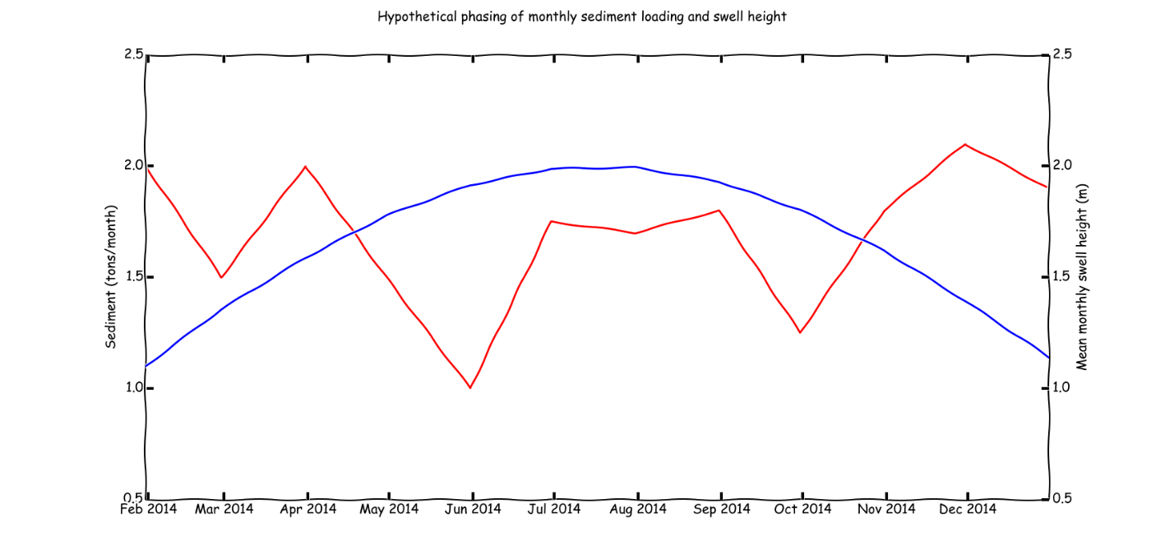

Figure 1. Hypothetical phasing of monthly sediment loading from the watershed and offshore swell height(Draut et al., 2009)

We hypothesize that rains during the wet season co-occur with light offshore winds and quiescent ocean conditions, when sediment can more readily settle on coral, increasing sedimentation rates of terrigenous material compared to comparable events in the dry season. In the dry season, we hypothesize that stronger, onshore trade winds and higher swell heights will decrease sedimentation rates of terrigenous sediment and shorten residence times, but will generate more sedimentation from marine-derived sources compared to the wet season. These two hypotheses will be tested with measurements of sediment accumulation, geochemical composition, particle size, watershed loading, and oceanic and meteorological conditions. The impact of watershed inputs, ocean conditions and meteorological conditions will be assessed with a statistically-based mathematical model.

## Pilot Study

In February and March, 2012 (Figure 1) I measured total sediment accumulation at nine locations on Faga’alu reef using simple tube traps (STT), a ceramic tile (TILE), and an Astroturf mat (MAT). From April 2013 through June 2013 I measured total sediment accumulation using SedPods (Field et al., 2012). Sediment accumulation varied according to sediment trap type, location, and ocean conditions, and included both reef-derived carbonate and terrigenous sediment. No assessment of sediment composition was made, but sediment accumulation rate appeared to be controlled by sediment input from Faga’alu stream, and hydrodynamic circulation caused by high wave events.

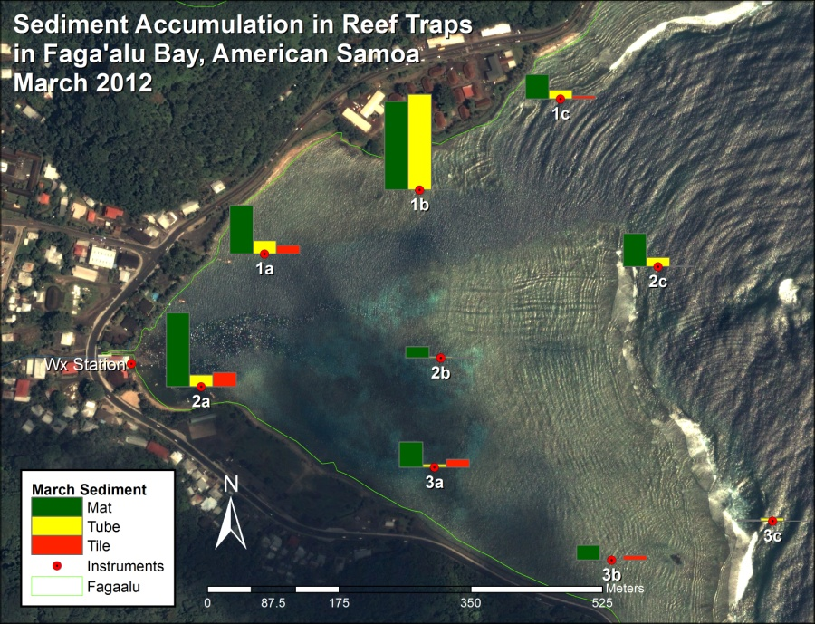

Figure 2 Gross sediment accumulation in tube, tile, and Astroturf sediment traps

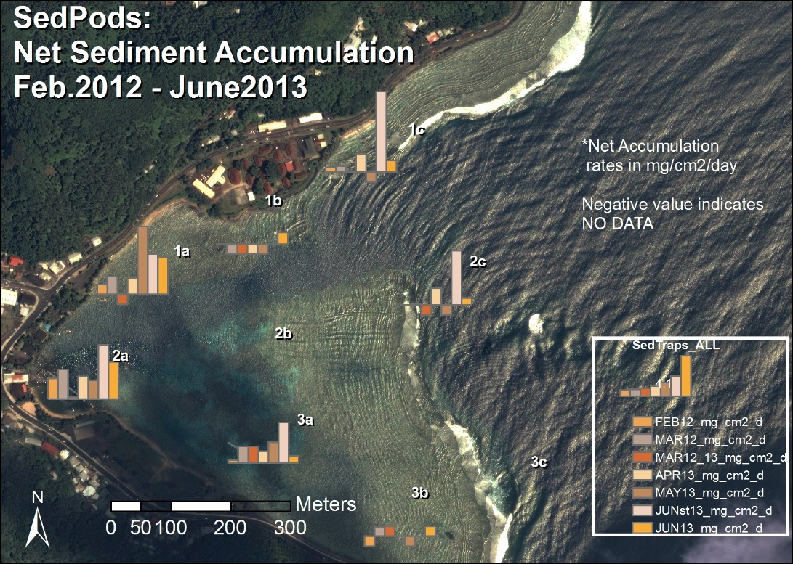

Figure 3 Net sedimentation on SedPods in Faga'alu Bay. Ceramic tiles were used in 2012 and were assumed to be comparable to SedPods.

## Research Questions

The research questions for this paper are:

1. Temporal controls:
   1. How do flood-supplied terrigenous sediment and hydrodynamic conditions interact to control the gross and net deposition rate of sediment at monthly time scales at different locations in Faga’alu Bay?
   2. Is there a seasonal pattern of sediment deposition and removal, with sediment being deposited during the wet season when storms coincide with quiescent ocean conditions and removed during the dry season when storms coincide with active ocean conditions?
2. Spatial controls:

What controls the spatial distribution of sediment deposition, and can it be predicted by the flow velocity and direction of water?

## Methods

### Measuring sediment accumulation on the reef

Approaches to measuring sediment impacts on coral health have included monitoring suspended sediment concentration or turbidity in the water column (Wolanski et al., 2003) but suspended sediment in the water column can be caused by resuspension of nearby sediment due to shear stresses induced by wave- orbital velocities and/or mean currents, advection from another area, or any combination of these processes, and does not necessarily lead to sediment deposition. Geochemical methods, sometimes in conjunction with coral skeleton analysis (Grove et al., 2010; Perry et al., 2012), have been used to infer sediment deposition over decadal and century time scales (Ryan et al., 2008) but can be complicated by subsequent sediment reworking and these time scales are ill-suited to the time scales of coral mortality and effective environmental management. Sediment traps are the most common method for measuring sediment accumulation in shallow coral reef environments, and collected sediment can be analyzed for composition to determine the terrigenous fraction (Gardner, 1980; Storlazzi et al., 2011; Takesue et al., 2009; White, 1990).

While measuring sediment accumulation on/in various devices is fairly straightforward, interpretation of the results can be complicated, making it difficult to infer hydrodynamic processes or possible effects on coral health (Storlazzi et al., 2011). On the Molokai reef, where sediment is resuspended and settles daily, daily clearing of the water column will contribute to sediment trap fluxes and cause an accumulation of sediment in the trap, yet may not contribute to accumulation rates on the seabed where sediment is resuspended in the next daily cycle. Tube traps, collect sediment over the deployment period, typically 1-90 days, yielding an integrated sample and average collection rate in mass per area per time, but Field et al. (2012) argue the collection rate is considered a gross collection rate since particles cannot be removed as they would be on natural benthic surfaces. Since tube traps slow the water column and prevent resuspension, they can effectively trap sediment that would have been advected through the area without being deposited (Storlazzi et al., 2011). To more accurately quantify “net” sedimentation, Field et al. (2012) proposed the use of “SedPods” where a flat, circular, roughened concrete surface is deployed which allows for resuspension, similar to the surrounding benthic substrate. Deploying a tube trap in conjunction with a SedPod provides a comparison of gross and net sediment accumulation, and an assessment of the interaction of sediment loading and removal at time scales relevant to coral mortality and management.

SedPods (Field, Chezar and Storlazzi 2012) and tube traps (Gray 2012, Storlazzi, Field and Bothner 2011) have been deployed at nine locations on the reef flat (water depth 1-2m) and reef crest (10-15m) in Faga’alu Bay, are being collected monthly to provide data on monthly sediment accumulation rates (mg/cm2/day) (Figure 2) from February 2014 through January 2015 (Victor et al., 2006). Collection will be performed by Messina when in the field and by Department of Marine and Wildlife Resources when Messina is not on-island. See QAPP 2.2.11.1-2.2.11.4.

### Sediment composition and particle size

Sediment samples collected in tubes and SedPods are wet sieved to separate the sand and fine fractions for analysis and rinse salt from the sample. The samples are dried and weighed to determine bulk sediment accumulation before being shipped to SDSU to characterize the geochemical composition (percent terrigenous, carbonate and organic) using Loss on Ignition (LOI) method (Gray et al., 2012; Heiri et al., 2001; Santisteban et al., 2004). The LOI method uses a muffler furnace that can sustain 950 C for several hours. All carbonate sediment is assumed to be reef derived, all non-carbonate is assumed to be terrigenous (Ryan et al., 2008). See QAPP 3.5. The particle size distribution and geochemical composition of sediment collected in traps may differ from sediment that accumulates on the reef, so sediments in the immediate area of the trap will also be sampled. See QAPP 2.2.11.5.

### Temporal variation in sediment accumulation

Sediment loading from the stream to the bay is an important control on sedimentation rates on corals but wave conditions decrease sediment deposition in two ways: 1) by flushing recently loaded sediment away from the corals before it can be deposited (in-phase with sediment discharge) and 2) resuspending and removing sediment that has been previously deposited (out-of-phase with sediment loading). Sediment loading out-of-phase with high swell conditions causes higher deposition rates and longer residence times than sediment loading in-phase with high swell conditions (Draut et al., 2009; Storlazzi et al., 2009).

Based on prior research (Aeby et al. 2006), Vetter (2013), and our pilot study, we hypothesize that sedimentation on the reef is controlled by both sediment loading from the watershed, sediment resuspension of reef-derived carbonate sediment, and variable oceanographic conditions that alter the amount, composition, and spatial distribution of sediment that settles on coral. This hypothesis will be tested using a combination of measured and modeled values of sediment loading from the watershed, using a model developed in Paper One of this proposal, and a model of water circulation and residence time developed in Paper Two of this proposal.

Statistical models, including both simple linear regression models and more complex generalized additive mixed models (GAMMs) will be used to establish the relative controls of each measured variable on sediment accumulation rates, both the average for North and South reefs, and at each of the nine locations where accumulation will be measured. The modeling approach is similar to other efforts that have attempted to limit the complexity of the modeling approach, but still account for the impact of ocean conditions on sedimentation (Fabricius et al. 2012).

We propose a semi-empirical model of sediment accumulation (Si) at location *i* in the bay during month *t* as:

|  |  |  |
| --- | --- | --- |
|  | $$S_{i}(t)=f\left(S_{w}(t),R(t),{SB}_{i}\right)$$ | Equation 1 |

where Sw(t) is sediment loading from the watershed in a given month, R(t) is water residence time over the reef flat (modeled as a function of mean monthly offshore wave energy and wind speed/direction), and SB is substrate type (live coral, dead coral, coralline sand, mud), which is a proxy for sediment availability in the microenvironment around the sampling location.

**Sediment Loading**

Field observations suggest that sediment larger than fine sand settle before reaching the corals. Sediment loading (Sw) refers to particle sizes less than 16um (fine sand). Monthly sediment loading from the watershed is calculated as the sum of suspended sediment yield from storm events (SSYi), using the model from paper 1:

|  |  |  |
| --- | --- | --- |
|  | $${SSY}_{i }^{*}= αQ_{max}^{β}$$ | Equation 1 |
| where the regression coefficients α and β are obtained by ordinary least squares regression on the logarithms of *SSYi* and *Qmax*. Suspended sediment from each event during the month is summed: | | |
|  | $${SSY}_{Month}= \sum_{i=1}^{n}{{SSY}_{i}}$$ | Equation 2 |
| where SSYMONTH is the sum of SSYEV for n events in the month. | | |

**Hydrodynamics**

Water residence time for each 100m x 100m grid cell containing a sediment trap/SedPod will be calculated from NOAA WaveWatch III swell model output and the model developed in Paper Two. Residence time is the amount of time a parcel of water remains in the grid cell, and is directly calculated from flow speed. We propose that residence time decreases with increased mean monthly swell height, and the relationship between swell height and flow speed in each grid cell will be determined in Paper Two, of the form:

|  |  |  |
| --- | --- | --- |
|  | $$R\left(t\right)=a{\overline{H_{s}}}^{-b}$$ | Equation 3 |
| where *R(t)* is the water residence time for month *t*, $\overline{H_{s}}$ is mean monthly swell height, and *a* and *b* are calibration coefficients. Depending on the modeling results from Paper Two, it may be necessary to calculate and average water residence time daily to determine mean monthly residence time. | | |

**Top Down**

It may be determined that sediment deposition is a function of sediment loading and water circulation processes interacting on daily time scales, where hydrodynamic conditions only on the day of sediment discharge and not the mean monthly condition, are important. If monthly sediment loading and monthly mean residence time do not adequately predict sediment accumulation in the sediment traps, it might be necessary to investigate sediment loading and water residence times on daily scales, and further refine the statistical analysis and equations. In that instance, daily sediment loading and daily mean flushing time will be used to assess daily deposition, which can be compared to the monthly sediment accumulation measurements.

**Monthly and Seasonal patterns of sediment deposition and removal**

Two time scales of analysis will be pursued: monthly and seasonal (dry and wet season). Monthly measurements of sediment loading, hydrodynamic conditions, and the subsequent sediment accumulation are used to assess the importance of controls on net sedimentation. A monthly time interval was chosen to correspond with other studies found in the literature (Muzuka et al., 2010; Victor et al., 2006), to sample enough storm events to collect enough sediment for analysis, and for logistical reasons due to the high spatial coverage of sites and limited field personnel and resources.

An assessment of differences between dry and wet season sediment dynamics is useful to determine if there are seasonal patterns or modes that may be relevant to long term sediment accumulation or coral conservation and restoration (Muzuka et al., 2010). Previous studies have focused on wet season sediment deposition (Muzuka et al., 2010; Victor et al., 2006) and may overestimate long term sediment accumulation. It is hypothesized that there is a season of net deposition during the wet season, and a season of net sediment removal, or limited deposition, in the dry season. The sediment accumulation data will be grouped by season and averaged to determine if there are seasonal patterns of net deposition/removal.

### Spatial variation of sediment accumulation (kernel values)

An important consideration for coral conservation is determining the spatial distribution of sediment impacts from terrigenous sediment loading. Current conservation models typically use the distance from the river mouth or other point source to assess pollution risk to coral reefs (Klein et al., 2012), but wave and wind-driven flow over the reef can deflect suspended sediment away from corals (Hoitink and Hoekstra, 2003). To explain the spatial variation of sediment accumulation between sediment traps, and determine if flow direction or distance from the stream is more important, a kernel-based approach will be used. The “kernel” is a method of analyzing spatial distribution by normalizing all measurements by the maximum observed measurement, which are then modeled as a function of water flow direction (towards/away the stream mouth) and distance from the stream mouth:

|  |  |  |
| --- | --- | --- |
|  | $$\frac{\overline{SedAcc}}{Max SedAcc}=f(V_{θ},d)$$ | Equation 4 |
| Where $\overline{SedAcc}$ is the mean sediment accumulation measured in each sediment trap, *Vϴ* is velocity in the direction away from the stream mouth, and *d* is distance from the stream mouth. | | |

## Expected Results/Outcomes

A serious problem faced by attempts by environmental managers and researchers to assess stress on reefs is the fact that there are few, if any, reefs with adequate baseline data (Risk, 2014). The proposed work will characterize and quantify the amount, geochemical composition, and particle sizes of sediment contributing to coral reef degradation in Faga’alu, informing mitigation strategies to reduce pollutant loading to the priority coral reef. The work will establish a baseline to measure the performance of future mitigation projects by developing a model that relates sediment loading from the watershed to sedimentation rates on the reef under varying oceanographic conditions.

It is hypothesized that net monthly sediment deposition is decreased by wave-driven circulation in Faga’alu Bay, both by flushing of sediment before it is deposited and by scouring of sediment that was deposited during quiescent ocean conditions; and net monthly sediment deposition is increased by loading of fine sediment to the bay. An additional hypothesis is that there is a phasing of sedimentation where wet season storms coincide with quiescent ocean conditions and sediment deposition is higher and more persistent than storms coinciding with active ocean conditions in the winter. The spatial distribution of sediment accumulation is hypothesized to be controlled by pattern of wave- and wind-driven flow of water from the ocean into the bay, that deflects the sediment discharged from the stream towards some areas of coral, and protects others from sedimentation effects.

The main outputs of the work will consist of a statistical model of sedimentation in Faga'alu Bay that quantifies the relative importance of watershed inputs and ocean circulation on sediment accumulation, and tests the above hypotheses.